

**AN EXPRESSIVE THERAPY**

Dance therapy focuses on movement behavior as it emerges in the therapeutic relationship. Expressive, communicative, and adaptive behaviors are all considered for group and individual treatment.

Dance therapy is practiced in mental health, rehabilitation, medical, educational settings, day care centers, health promotion programs and in private practice.

It is effective for individuals with developmental, medical, social, physical, and psychological impairments. Dance can be used with people of all ages, ethnic backgrounds, in individuals, couples, family and group therapy formats.

Dance allows changes in feelings, cognition, physical functioning, and behavior in the body and mind of the individual.

The mind-body relationship of dance corresponds with the holistic approach occupational therapists base their therapeutic treatment approaches. Dance focuses on the connection between the mind and body to promote health and healing. Dance values creativity and the individuality of the client.

“the symbols of the self arise in the depths of the body.” – C.G. Jung

Anyone who has interpersonal communication and/or emotional problems  
Neurotic Individuals  
Psychotic individuals  
Physically challenged  
Developmental disabled  
Veterans  
School children at risk  
Learning Disabled  
Elderly  
Stroke victims  
People with AIDS  
Substance Abusers

American Dance Therapy Association. (2009). *About dance movement therapy*. Retrieved from http://www.adta.org/Default.aspx?pageId=378213

**WHO BENEFITS FROM INDIVIDUAL AND GROUP DANCE THERAPY**

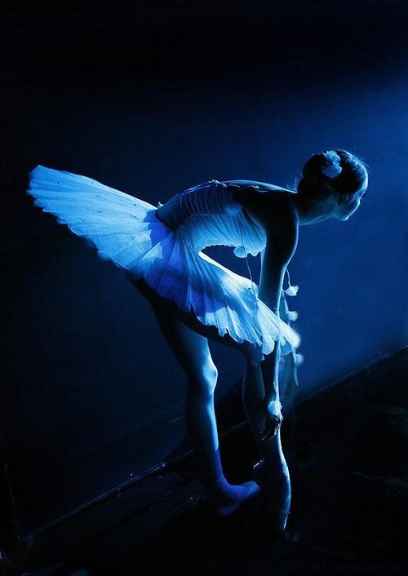

Psychotherapeutic use of movement to further the emotional, cognitive, physical and social integration of the individual

Dance Therapy

**­**